THE EFFECT OF RESIDUAL STRESSES ON FATIGUE CRACK GROWTH
IN WELDED STIFFENED PANELS

A. Firstauthorfamilyname ¹, Ž. Božić ^{2, *}, B.B. Thirdauthorfamilyname ³
¹University, School, Address, City, Country
²University of Zagreb, Faculty of Mech. Eng. And Nav. Arch., I. Lučića 5, 10000 Zagreb, Croatia
³University, School, Address, City, Country

The crack growth rate in welded stiffened panels can be significantly affected by the residual stresses which are introduced by the welding process. The influence of welding residual stress on crack growth rate is accounted for by replacing the nominal stress ratio R in empirical power laws by the effective stress intensity factor ratio R_{eff} [1, 2]. The analysis method is based on the superposition rule of linear elastic fracture mechanics. In the residual stress field, under the cyclic loads, the total SIF range ΔK_{tot} and effective SIF ratio R_{eff} are given as:
$∆K_{tot}=\left(K_{app,max}+K_{res}\right)-\left(K_{app,min}+K_{res}\right)=∆K_{app}$ (1)
In this study the distribution of welding residual stresses in the stiffened panel specimen is depicted in Figures 1a and 1b.

- 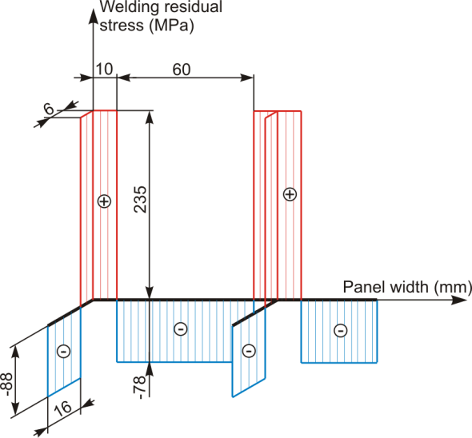 b) 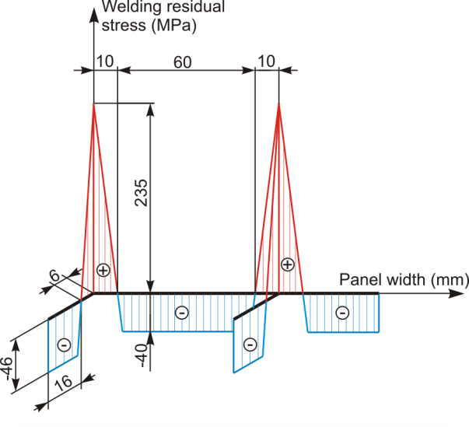

Fig. 1. Welding residual stress distribution: a) rectangular; b) triangular.

Compressive welding residual stresses decreased the total SIF values K_{tot}, and the crack growth rate between the two stiffeners. The Elber and Schijve models, which take into account the effective stress intensity factor ratio, R_{eff}, were implemented to simulate fatigue crack propagation in the test specimen. The simulated crack growth rate was higher in the region of tensile residual stresses, which is in good agreement with experimental results.

References
[1] Božić Ž, Schmauder S, Mlikota M, Hummel M. Multiscale fatigue crack growth modelling for welded stiffened panels. Fatigue and Fracture of Engineering Materials and Structures 2014; 37(9):1043–1054.
[2] Servetti G, Zhang X. Predicting fatigue crack growth rate in a welded butt joint: the role of effective R ratio in accounting for residual stress effect. Eng. Fract. Mech. 2009; 76: 1589–1602.

